**ECE521 Assignment 4**

Written by

Winston Wong (1001614853)

Date: 2017-04-08

**1.1.1**

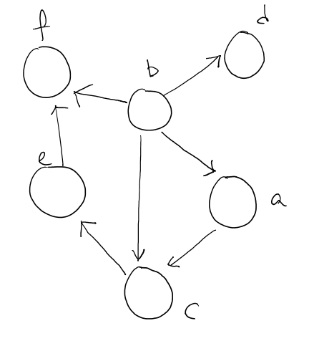

**1.1.2**

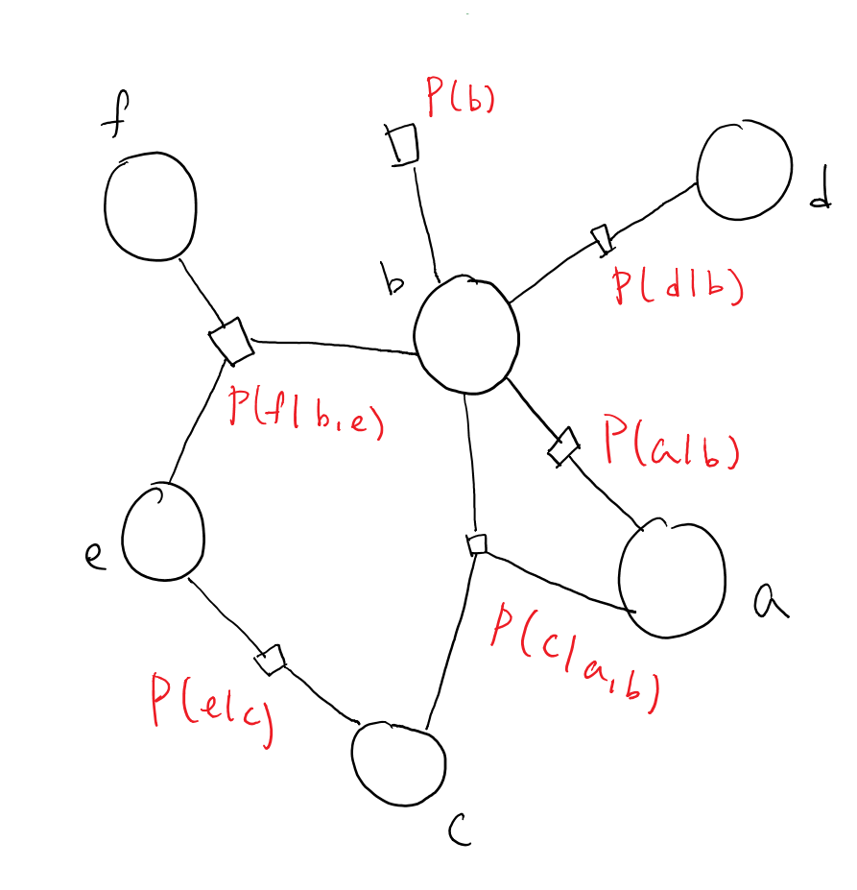

**1.1.3**

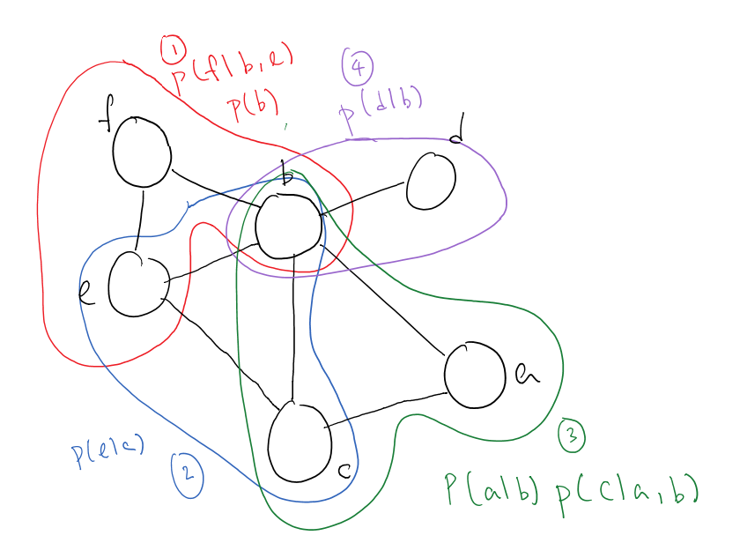

**1.2.1.1a)**

|  |  |  |
| --- | --- | --- |
|  | Factor Graph  (given in question) | Bayesian Network |
| Graph |  |  |
| $$a⊥b?$$ | False | False |
| $$b⊥c?$$ | False | False |
| $$a⊥c?$$ | False | False |
|  | False | False |
|  | False | False |
|  | False | False |

Conditional Probabilities in terms of factors using sum-product algorithm

$$p\left(b | a\right)=\frac{p\left(a,b\right)}{p\left(a\right)}=\frac{\sum_{c}{f_{1}\left(a,b,c\right)f_{2}\left(a\right)}}{\sum_{b,c}{f_{1}\left(a,b,c\right)f_{2}\left(a\right)}}=\frac{f_{1}\left(a,b\right)}{f_{1}\left(a\right)}$$

$$p\left(c | a\right)=\frac{p\left(a,c\right)}{p\left(a\right)}=\frac{\sum_{b}{f_{1}\left(a,b,c\right)f_{2}\left(a\right)}}{\sum_{b,c}{f_{1}\left(a,b,c\right)f_{2}\left(a\right)}}=\frac{f_{1}\left(a,c\right)}{f_{1}\left(a\right)}$$

$$p\left(b | c\right)=\frac{p\left(b,c\right)}{p\left(c\right)}=\frac{\sum_{a}{f_{1}\left(a,b,c\right)f_{2}\left(a\right)}}{\sum_{a,b}{f_{1}\left(a,b,c\right)f_{2}\left(a\right)}}$$

$$p\left(a | b,c\right)=\frac{p\left(a,b,c\right)}{p\left(b,c\right)}=\frac{f_{1}\left(a,b,c\right)f_{2}\left(a\right)}{\sum_{a}{f_{1}\left(a,b,c\right)f_{2}\left(a\right)}}$$

$$p\left(c | a,b\right)=\frac{p\left(a,b,c\right)}{p\left(a,b\right)}=\frac{f_{1}\left(a,b,c\right)f_{2}\left(a\right)}{\sum_{c}{f_{1}\left(a,b,c\right)f_{2}\left(a\right)}}=\frac{f_{1}\left(a,b,c\right)}{f_{1}\left(a,b\right)}$$

$$p\left(b | a,c\right)=\frac{p\left(a,b,c\right)}{p\left(a,c\right)}=\frac{f_{1}\left(a,b,c\right)f_{2}\left(a\right)}{\sum_{b}{f_{1}\left(a,b,c\right)f_{2}\left(a\right)}}=\frac{f_{1}\left(a,b,c\right)}{f_{1}\left(a,c\right)}$$

**1.2.1.1b)**

**NOTE**: A Bayesian Network representation of the factor graph below is impossible if

$$∄ i,j∈\left\{1,2,5\right\} st f_{i}f_{j}=f_{i}$$

This is because the factors $f_{1}$ and $f_{2}$ indicates that b and c have no parent but $f_{5}$ indicates there’s conditional dependence between the two. Thus either b is the parent or c is the parent, which is a contradiction.

However, if we relax our assumption, that is, assume $∃ i,j∈\left\{1,2,5\right\} st f_{i}f_{j}=f_{i}$, Then the simplified factor graph can be converted to the BN as follows.

|  |  |  |
| --- | --- | --- |
|  | Factor Graph  (given in question) | Bayesian Network |
| Graph |  |  |
| $$a⊥b?$$ | False | False |
| $$b⊥c?$$ | False | False |
| $$a⊥c?$$ | False | False |
|  | False | False |
|  | False | False |
|  | False | False |

The conditional Probabilities in terms of factors are computed as follows.

$$p\left(b | a\right)=\frac{p\left(a,b\right)}{p\left(a\right)}=\frac{\sum_{c}{f_{1}\left(b\right)f_{2}\left(c\right)f_{3}\left(a,b\right)f_{4}\left(a,c\right)f_{5}\left(b,c\right)}}{\sum_{b,c}{f_{1}\left(b\right)f_{2}\left(c\right)f_{3}\left(a,b\right)f_{4}\left(a,c\right)f_{5}\left(b,c\right)}}$$

$$p\left(c | a\right)=\frac{p\left(a,c\right)}{p\left(a\right)}=\frac{\sum_{b}{f_{1}\left(b\right)f_{2}\left(c\right)f_{3}\left(a,b\right)f_{4}\left(a,c\right)f_{5}\left(b,c\right)}}{\sum_{b,c}{f_{1}\left(b\right)f_{2}\left(c\right)f_{3}\left(a,b\right)f_{4}\left(a,c\right)f_{5}\left(b,c\right)}}$$

$$p\left(b | c\right)=\frac{p\left(b,c\right)}{p\left(c\right)}=\frac{\sum_{a}{f_{1}\left(b\right)f_{3}\left(a,b\right)f_{4}\left(a,c\right)f_{5}\left(b,c\right)}}{\sum_{a,b}{f_{1}\left(b\right)f_{3}\left(a,b\right)f_{4}\left(a,c\right)f_{5}\left(b,c\right)}}$$

$$p\left(a | b,c\right)=\frac{p\left(a,b,c\right)}{p\left(b,c\right)}=\frac{f_{3}\left(a,b\right)f_{4}\left(a,c\right)}{\sum_{a}{f_{3}\left(a,b\right)f_{4}\left(a,c\right)}}$$

$$p\left(b | a,c\right)=\frac{p\left(a,b,c\right)}{p\left(a,c\right)}=\frac{f_{1}\left(b\right)f_{3}\left(a,b\right)f_{5}\left(b,c\right)}{\sum_{b}{f_{1}\left(b\right)f_{3}\left(a,b\right)f_{5}\left(b,c\right)}}$$

$$p\left(c | a,b\right)=\frac{p\left(a,b,c\right)}{p\left(a,b\right)}=\frac{f_{2}\left(c\right)f_{4}\left(a,c\right)f_{5}\left(b,c\right)}{\sum_{c}{f_{2}\left(c\right)f_{4}\left(a,c\right)f_{5}\left(b,c\right)}}$$

**1.2.1.2a)**

|  |  |  |
| --- | --- | --- |
|  | Factor Graph  (given in question) | Markov Random field |
| Graph |  |  |
| $$a⊥b?$$ | False | False |
| $$b⊥c?$$ | False | False |
| $$a⊥c?$$ | False | False |
|  | False | False |
|  | False | False |
|  | False | False |

$$ψ\left(a,b\right)=f_{1}\left(a,b\right)f_{2}\left(a\right)$$

$$ψ\left(a,c\right)=f_{1}\left(a,c\right)f_{2}\left(a\right)$$

$$ψ\left(b,c\right)=f_{1}\left(b,c\right)$$

$$ψ\left(a,b,c\right)=f_{1}\left(a,b,c\right)f_{2}\left(a\right)$$

**1.2.1.2b)**

|  |  |  |
| --- | --- | --- |
|  | Factor Graph  (given in question) | Markov Random field |
| Graph |  |  |
| $$a⊥b?$$ | False | False |
| $$b⊥c?$$ | False | False |
| $$a⊥c?$$ | False | False |
|  | False | False |
|  | False | False |
|  | False | False |

$$ψ\left(a,b\right)=f_{3}\left(a,b\right)f_{1}\left(b\right)f_{5}\left(b\right)f_{4}(a)$$

$$ψ\left(a,c\right)=f_{4}\left(a,c\right)f_{5}\left(c\right)f_{2}(c)f_{3}(a)$$

$$ψ\left(b,c\right)=f_{5}\left(b,c\right)f_{1}\left(b\right)f_{3}\left(b\right)f_{2}\left(c\right)f_{4}(c)$$

$$ψ\left(a,b,c\right)=f_{1}\left(b\right)f_{2}\left(c\right)f_{3}\left(a,b\right)f_{4}\left(a,c\right)f_{5}\left(b,c\right)$$

**1.2.2.1**

|  |  |  |
| --- | --- | --- |
|  | Markov Random field  (given in question) | Factor graph |
| Graph |  |  |
|  | False | False |
|  | False | False |
|  | False | False |
|  | False | False |
|  | False | False |
|  | False | False |
|  | False | False |
|  | False | False |
|  | True | True |
|  | False | False |
|  | False | False |
|  | False | False |
|  | False | False |
|  | False | False |
|  | True | True |
|  | False | False |
|  | False | False |
|  | False | False |

**1.2.2.2**

No. First given that $a⊥c | b, d$ and $b⊥d| a, c$ are true for the given MRF, there cannot be any connections between the diagonal vertices in BN. Thus we look at the BNs without diagonal connection $\{e_{bd}, e_{ac}\}$, with only 4 edges connecting the adjacent vertices $\{e_{ad},e_{dc}, e_{cb}, e_{ba}\}$ Moreover, the $2^{4}$ combinations made by the 4 edges in the graph can be boiled down to 3 by Symmetry, as follows. It is obvious that adjacent nodes are always conditionally dependent. We investigate conditional independence between diagonal vertices.

|  |  |  |
| --- | --- | --- |
| 2 “head to tail” arrows | 3 “head to tail arrows” | 4 head to tail arrows |
|  |  |  |
| FALSE | FALSE | NOT POSSIBLE SINCE BN CONTAINS CYCLE |
| FALSE | FALSE |
| FALSE | FALSE |
| TRUE | TRUE |

In both cases, there exists one conditional independence between the diagonal vertices.

**1.3.1**

$$p\left(a,b,c,d,e,f\right)=p\left(a\right)p\left(b | a\right)p\left(c | b,e\right)p\left(d | b,c\right)p\left(e\right)p(f|b)$$

**1.3.2**

|  |  |
| --- | --- |
| $$a⊥ c$$ | FALSE |
|  | TRUE |
| $$e⊥ b$$ | TRUE |
|  | FALSE |
| $$a⊥ e$$ | TRUE |
|  | FALSE |

**3.1.1**

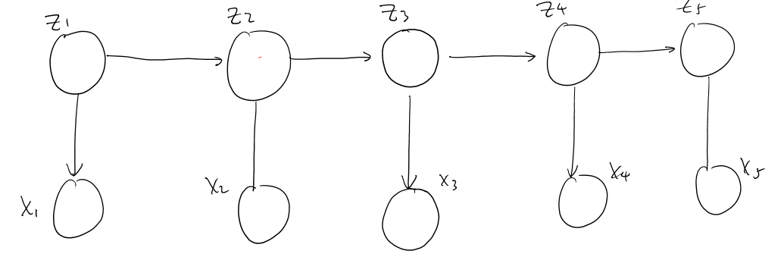

**3.1.2**

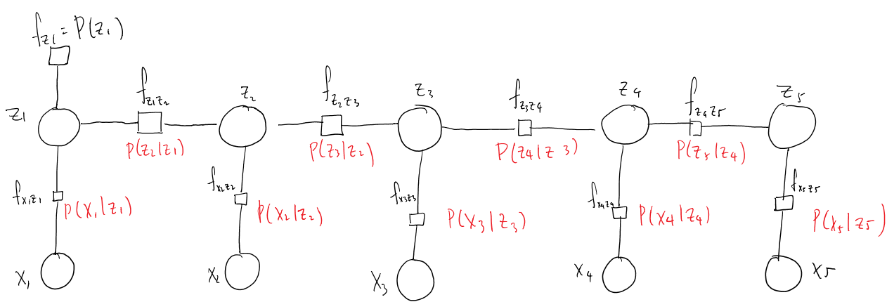

**3.2.1**

$$μ_{z_{4}→f_{z_{3}z_{4}}}\left(z_{4}\right)=\prod_{f_{i}∈Ne\left(z_{4}\right)}{μ_{f_{i}→z_{4}}\left(z_{4}\right)}$$

$$μ_{z_{4}→f_{z_{3}z_{4}}}\left(z_{4}\right)=μ_{f_{z_{4}z_{5}}→z_{4}}(z_{4})μ_{f_{x_{4}z_{4}}→z_{4}}(z_{4})$$

**3.3.1 NOTE: $∙$ denotes element-wise product**

$$f_{x_{1}z_{1}}\left(x_{1},z_{1}\right)=\left(\begin{matrix}\begin{matrix}f\left(x_{1}=1,z_{1}=1\right) & f\left(x_{1}=2,z_{1}=1\right) \\ f\left(x_{1}=1,z_{1}=2\right) & f\left(x_{1}=2,z_{1}=2\right)\end{matrix} & \begin{matrix}⋯ & f\left(x_{1}=M,z_{1}=1\right) \\ ⋯ & f\left(x_{1}=M,z_{1}=2\right)\end{matrix} \\ \begin{matrix}⋮ & ⋮ \\ f\left(x_{1}=1,z_{1}=K\right) & f\left(x_{1}=2,z_{1}=K\right)\end{matrix} & \begin{matrix}⋱ & ⋮ \\ ⋯ & f\left(x_{1}=M,z_{1}=K\right)\end{matrix}\end{matrix}\right)$$

Where

$$f_{x_{1}z_{1}}\left(x_{1}=i,z_{1}=j\right)=P(x_{1}=i|z_{1}=j)$$

$$W=\left(\begin{matrix}\begin{matrix}P(x_{1}=1|z_{1}=1) & P(x_{1}=1|z_{1}=2) \\ P(x_{1}=2|z_{1}=1) & P(x_{1}=2|z_{1}=2)\end{matrix} & \begin{matrix}⋯ & P(x_{1}=1|z_{1}=K) \\ ⋯ & P(x_{1}=2|z_{1}=K)\end{matrix} \\ \begin{matrix}⋮ & ⋮ \\ P(x_{1}=M|z_{1}=1) & P(x_{1}=M|z_{1}=2)\end{matrix} & \begin{matrix}⋱ & ⋮ \\ ⋯ & P(x_{1}=M|z_{1}=K)\end{matrix}\end{matrix}\right)$$

Moreover

$$f_{z_{1}z_{2}}\left(z{}_{1},z_{2}\right)=\left(\begin{matrix}\begin{matrix}f\left(z_{1}=1,z_{2}=1\right) & f\left(z_{1}=2,z_{2}=1\right) \\ f\left(z_{1}=1,z_{2}=2\right) & f\left(z_{1}=2,z_{2}=2\right)\end{matrix} & \begin{matrix}⋯ & f\left(z_{1}=K,z_{2}=1\right) \\ ⋯ & f\left(z_{1}=K,z_{2}=2\right)\end{matrix} \\ \begin{matrix}⋮ & ⋮ \\ f\left(z_{1}=1,z_{2}=K\right) & f\left(z_{1}=2,z_{2}=K\right)\end{matrix} & \begin{matrix}⋱ & ⋮ \\ ⋯ & f\left(z_{1}=K,z_{2}=K\right)\end{matrix}\end{matrix}\right)$$

$$f_{z_{1}z_{2}}\left(z_{1}=i,z_{2}=j\right)=P(z_{2}=i|z_{1}=j)$$

$$T= \left(\begin{matrix}\begin{matrix}P(z_{2}=1|z_{1}=1) & P(z_{2}=1|z_{1}=2) \\ P(z_{2}=2|z_{1}=1) & f\left(z_{1}=2,z_{2}=2\right)\end{matrix} & \begin{matrix}⋯ & P(z_{2}=1|z_{1}=K) \\ ⋯ & f\left(z_{1}=2,z_{2}=K\right)\end{matrix} \\ \begin{matrix}⋮ & ⋮ \\ f\left(z_{1}=K,z_{2}=1\right) & f\left(z_{1}=K,z_{2}=2\right)\end{matrix} & \begin{matrix}⋱ & ⋮ \\ ⋯ & f\left(z_{1}=K,z_{2}=K\right)\end{matrix}\end{matrix}\right)$$

Thus

$$f_{x_{1}z_{1}}\left(x_{1},z_{1}\right)=W^{T}$$

$$μ_{f_{x_{1}z_{1}}→z_{1}}\left(z_{1}\right)=\sum_{x_{1}}{f_{x_{1}z_{1}}\left(x_{1},z_{1}\right)μ_{x_{1}→f_{x_{1}z_{1}}}\left(x_{1}\right)}=W^{T}x_{1}$$

$$μ_{f_{z_{1}}→z_{1}}\left(z_{1}\right)=π$$

$$μ_{z_{1}→f_{z_{1}z_{2}}}\left(z_{1}\right)=μ_{f_{z_{1}}→z_{1}}\left(z_{1}\right)∙μ_{f_{x_{1}z_{1}}→z_{1}}\left(z_{1}\right)= π∙W^{T}x_{1}$$

$$f_{x_{2}z_{2}}\left({x_{2},z}_{2}\right)=W^{T}$$

$$μ_{f_{x_{2}z_{2}}→z_{2}}\left(z_{2}\right)=\sum_{x_{2}}{f_{x_{2}z_{2}}\left({x_{2},z}_{2}\right) μ_{x_{2}→f_{x_{2}z_{2}}}\left(x_{2}\right)}=W^{T}x_{2}$$

$$f_{z_{1}z_{2}}\left(z_{1},z_{2}\right)=T$$

$$μ_{f_{z_{1}z_{2}}→z_{2}}\left(z_{2}\right)=\sum_{z_{1}}{f_{z_{1}z_{2}}\left(z_{1},z_{2}\right)μ_{z_{1}→f_{z_{1}z_{2}}}\left(z_{1}\right)}=T(π∙W^{T}x_{1})$$

$$μ_{z_{2}→f_{z_{2}z_{3}}}\left(z_{2}\right)= μ_{f_{z_{1}z_{2}}→z_{2}}\left(z_{2}\right)∙μ_{f_{x_{2}z_{2}}→z_{2}}\left(z_{2}\right)=\left(T(π∙W^{T}x_{1})\right)∙\left(W^{T}x_{2}\right)$$

$$f_{z_{2}z_{3}}\left(z_{2}, z_{3}\right)=T$$

$$μ_{f_{z_{2}z_{3}}→z_{3}}\left(z_{3}\right)=\sum_{z_{2}}{f_{z_{2}z_{3}}\left(z_{2}, z_{3}\right) μ_{z_{2}→f_{z_{2}z_{3}}}(z_{2})}=T\left(\left(T(π∙W^{T}x_{1})\right)∙\left(W^{T}x_{2}\right)\right)$$

**3.3.2 NOTE: $∙$ denotes element-wise product**

$$μ_{f_{x_{5}z_{5}→z_{5}}}\left(z_{5}\right)=\sum_{x_{5}}{f_{x_{5}z_{5}}\left(x_{5}, z_{5}\right) μ_{x_{5}→f_{x_{5}z_{5}}}\left(x_{5}\right)=W^{T}x_{5}}$$

$$μ_{z_{5}→f_{z_{4}z_{5}}}\left(z_{5}\right)=μ_{f_{x_{5}z_{5}→z_{5}}}(z_{5})=W^{T}x_{5}$$

$$μ_{f_{z_{4}z_{5}}→z_{4}}\left(z_{4}\right)=\sum_{z_{5}}{f_{z_{4}z_{5}}\left(z_{4}, z_{5}\right) μ_{z_{5}→f_{z_{4}z_{5}}}\left(z_{5}\right)}=T^{T}W^{T}x_{5}$$

Notice, here we are summing ${ f}_{z_{i}z_{i+1}}\left(z_{i}, z_{i+1}\right)$ over $z_{i+1}$ (NOT over $z_{i}$ as in the previous question). This is equivalent to multiplying $T^{T}$ not $T$

$$μ_{f_{x_{4}z_{4}}→z_{4}}\left(z_{4}\right)=\sum_{x_{4}}{f_{x_{4}z_{4}}\left(x_{4}, z_{4}\right) μ_{x_{4}→f_{x_{4}z_{4}}}\left(x_{4}\right)}=W^{T}x_{4}$$

$$μ_{z_{4}→f_{z_{3}z_{4}}}\left(z_{4}\right)= μ_{f_{z_{4}z_{5}}→z_{4}}\left(z_{4}\right)∙μ_{f_{x_{4}z_{4}}→z_{4}}\left(z_{4}\right)=\left(T^{T}W^{T}x_{5}\right)∙\left(W^{T}x_{4}\right)$$

$$μ_{f_{z_{3}z_{4}}→z_{3}}\left(z_{3}\right)=\sum_{z_{4}}{f_{z_{3}z_{4}}\left(z_{3}, z_{4}\right) μ_{z_{4}→f_{z_{3}z_{4}}}\left(z_{4}\right)}=T^{T}\left(\left(T^{T}W^{T}x_{5}\right)∙\left(W^{T}x_{4}\right)\right)$$

$$μ_{f_{x_{3}z_{3}}→z_{3}}\left(z_{3}\right)=\sum_{x_{3}}{f_{x_{3}z_{3}}\left(x_{3}, z_{3}\right) μ_{x_{3}→f_{x_{3}z_{3}}}(x_{3})}=W^{T}x_{3}$$

$$μ_{z_{3}→f_{z_{2}z_{3}}}\left(z_{3}\right)= μ_{f_{z_{3}z_{4}}→z_{3}}\left(z_{3}\right)∙μ_{f_{x_{3}z_{3}}→z_{3}}\left(z_{3}\right)=\left(T^{T}\left(\left(T^{T}W^{T}x_{5}\right)∙\left(W^{T}x_{4}\right)\right)\right)∙\left(W^{T}x_{3}\right)$$